AtlasAsset
Architecture/Design Document

Table of Contents

1 Introduction……………………………………………………………………………3
2 Design Goals…………………………………………………………………………3
3 System Behavior…………………………………………………………………….4
4 Logical View…………………………………………………………………………4
4.1 High-Level Design…………………………………………………………….4
4.2 Mid-Level Design……………………………………………………………..5
4.3 Detailed Data/Class Design……………………………………………………6
5 Process View…………………………………………………………………………6
6 Development View………………………………………………………………….8
7 Physical View………………………………………………………………………..9
8 Use Case View………………………………………………………………………9

Change History

Version: 0.0

Modifier: Ashli Johnson

Date: 3/5/2026

Description of Change: Initial rough draft. Contains logical view (high-level modules only) and development view.

______________________________________________________

Version: 0.5

Modifier: Fardowsa Muhumed

Date: 4/20/2026

Description of Change: Added process view and use case view. Added sequence diagrams to logical view.

______________________________________________________

Version: 1.0

Modifier: Ashli Johnson & Fardowsa Muhumed

Date: 5/01/2026

Description of Change: Added detailed class diagrams, physical view, and deployment architecture. Finalized for stakeholder review.

_____________________________________________________

1 Introduction
This document describes the architecture and design for AssetAtlas. The system is a web-based personal finance application that allows users to register, log in, manage accounts, record transactions, organize spending by category and merchant, manage budgets, track debts and lenders, and view dashboard summaries.
The application is organized as a React/Vite frontend, a Flask REST API backend, and a PostgreSQL database. The backend uses SQLAlchemy models, a database session layer, Flask blueprints for endpoint grouping, JWT-based authentication, and CORS support for frontend-to-backend communication.
The purpose of this document is to explain the structure of the project in a way that helps users, developers, project managers, and maintenance programmers understand how the major parts of the system fit together.
Major stakeholders for this application are:
- Users and Commerce Bank (the customer) – They want assurances that the architecture provides system functionality and exhibits desirable non-functional qualities such as security, usability, and reliability.
- Developers (Ashli, Imanol, Travon) – They want an architecture that minimizes complexity and development effort, with clear separation between frontend, backend, and database concerns.
- Project Manager (Fardowsa) – She wants an architecture that divides the system into components of roughly equal size and complexity that can be developed simultaneously with minimal dependencies.
- Maintenance Programmers – They want assurance that the system will be easy to evolve and maintain into the future.

2 Design Goals
There is no absolute measure for distinguishing between good and bad design. The value of a design depends on stakeholder priorities. The design that is offered will be judged according to how well it satisfies the stated priorities. The priorities for the design that follows are:
- Separate frontend, backend routing, business/data logic, and database concerns so team members can work independently.
- Keep API endpoints consistent under the /api prefix so the frontend has a predictable integration point.
- Protect user-specific resources with JWT authentication and user ownership checks.
- Use SQLAlchemy models and relationships to keep database access organized and easier to maintain.
- Support local development through Docker Compose and production deployment through environment-based database configuration.

3 System Behavior
At a high level, users interact with the frontend in a browser. The frontend sends HTTP requests to the Flask backend. The backend validates requests, checks authentication when needed, performs business logic through route handlers and service objects, queries or updates the PostgreSQL database through SQLAlchemy, and returns JSON responses to the frontend.
The table below summarizes the core user actions and how the backend responds:
User Action | Backend Behavior | Expected Result
Register account | Validate required fields, create user, save security question/answer | New user record is created
Log in | Authenticate credentials and create JWT access token | Frontend stores token for protected requests
Add transaction | Verify account belongs to current user and insert transaction | Transaction appears in account/dashboard views
Filter transactions | Apply month, year, and category filters | Filtered transaction list returned
View dashboard | Aggregate account, budget, transaction, and debt data | User sees financial summary

4 Logical View
The logical view describes the main software components and the relationships between them.

4.1 High-Level Design
The system has five major logical components: frontend user interface, Flask API application control, authentication/security, SQLAlchemy models/services, and PostgreSQL database storage.

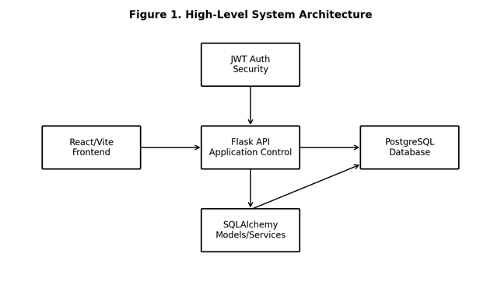
Figure 1. High-Level System Architecture
Component descriptions:
- React Frontend – Provides the user interface. Handles client-side routing, state management, API calls, and renders financial data using Material-UI components and Recharts.
- Flask Backend – Provides RESTful API endpoints. Contains authentication logic, business rules, and data validation. Acts as the intermediary between frontend and database.
- PostgreSQL Database – Persists all user data, account information, transactions, debts, and budget settings.
- JWT Authentication – Provides stateless authentication. The frontend stores the token and includes it in every authenticated request.

4.2 Mid-Level Design
The backend uses blueprints to separate endpoint groups. The app registers routes for auth, transactions, dashboard, budgets, debts, accounts, categories, merchants, lenders, addresses, users, and transfers. The frontend is a React/Vite application that calls these endpoints through HTTP requests.

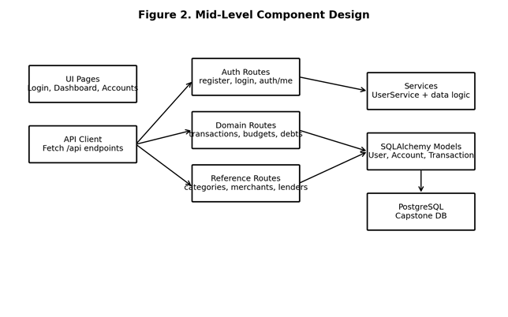
Figure 2. Mid-Level Component Design

4.3 Detailed Data/Class Design
The central data model is user-centered. A User owns Accounts and Budgets. Accounts own Transactions. Transactions can optionally reference Categories and Merchants. Accounts can optionally reference Lenders. This structure supports a personal finance system where each user only sees and manages their own financial data.
Entity | Key Fields | Relationships | Responsibility
User | id, username, email, password_hash | Has many accounts and budgets | Stores login/profile and notification settings
Account | id, user_id, lender_id, balance | Belongs to user; has many transactions | Stores checking, savings, loan, or other account records
Transaction | id, account_id, category_id, merchant_id, amount, date | Belongs to account; may use category and merchant | Stores financial activity
Budget | id, user_id, category_id, amount, month, year | Belongs to user and category | Stores monthly category spending limits
Category | id, name, type | Has many transactions | Organizes income/expense types
Merchant | id, name, default_category | Has many transactions | Stores business/payee data
Lender | id, name | Referenced by account | Stores lender information for debts/loans

5 Process View
The system is request/response based. The frontend runs in the browser. The Flask application receives HTTP requests and handles each request through the appropriate route. Database work is performed through a SQLAlchemy session, which is closed after the route finishes. Protected routes use JWT middleware to determine the current user before accessing data.

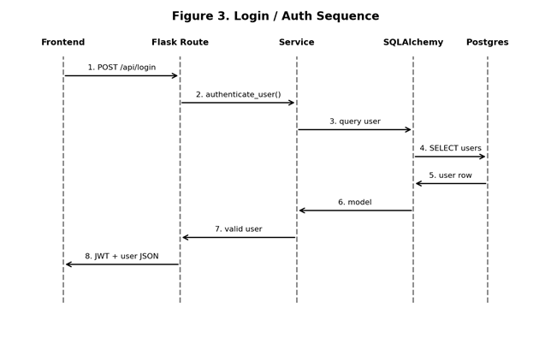
Figure 3. Login / Auth Sequence

6 Development View
The repository is divided into frontend, backend routing, application models, services, database configuration, migrations, tests, and deployment configuration.
Repository Area | Main Contents | Development Responsibility
frontend/ | React/Vite source, package.json, Vite config | Build UI pages and API calls
routes/ | Flask blueprint route files | Define REST API endpoints and request validation
app/models/ | SQLAlchemy entity classes | Maintain database schema objects and relationships
app/services/ | Business/data service helpers | Keep reusable logic out of route files
app/database.py | Engine, SessionLocal, Base | Central database connection setup
alembic/ | Database migrations | Track schema changes
docker-compose.yml and Dockerfile | Local containers for web and database | Run consistent development environment
requirements.txt | Python dependencies | Backend package management

7 Physical View
For local development, Docker Compose defines a PostgreSQL 15 database container and a web container built from the project. The database is exposed on host port 5433 and container port 5432. The web service connects to the database using DATABASE_URL.
For deployment, the database configuration reads a single DATABASE_URL environment variable and adjusts postgres/postgresql connection strings for SQLAlchemy compatibility.

8 Use Case View

Register and Log In
1. User submits registration details from frontend.
2. Backend validates required fields and creates the user.
3. User submits email and password.
4. Backend authenticates the user and returns a JWT access token.
5. Frontend includes the token on protected API requests.

Create Transaction
6. User opens transaction form and enters account, amount, category, merchant, description, and date.
7. Backend verifies the account belongs to the current user.
8. Backend saves the transaction and returns the created transaction JSON.
9. Frontend updates the transaction list and dashboard.

View Monthly Budget Status
10. User opens budget/dashboard view.
11. Frontend calls protected budget and dashboard endpoints.
12. Backend retrieves user budgets and spending for the selected period.
13. System displays remaining budget and spending progress by category.

Document Storage
This document is stored in the project's Git repository at:
https://github.com/ashlinjohnson/Capstone_Project
Additional project documents and assets are stored in the team's Google Drive folder at:
https://drive.google.com/drive/folders/13nkU5rMXic4u0EmYyCLt71OMjird5Dcf?usp=sharing

